Jesus said, “If you abide in My Word, you are truly My disciples,
and you will know the truth, and the truth will set you free.”

The Festival of the Reformation
October 27, 2019

9:30 a.m.

This Morning’s Hymns
497 657 617 578 644 561 556

The Seal of Martin Luther

“There is first to be a cross, black and placed in a heart, which should be of its natural color, so that I myself would be reminded that faith in the Crucified saves us. For if one believes from the heart he will be justified. Even though it is a black cross, which mortifies and which also should hurt us, yet it leaves the heart in its natural color and does not ruin nature; that is, the cross does not kill but keeps man alive. For the just man lives by faith, but by faith in the Crucified One. Such a heart is to be in the midst of a white rose, to symbolize that faith gives joy, comfort, and peace; in a word, it places the believer into a white joyful rose; for this faith does not give peace and joy as the world gives and, therefore, the rose is to be white and not red, for white is the color of the spirits and of all the angels. Such a rose is to be in a sky-blue field, symbolizing that such joy in the Spirit and in faith is a beginning of the future Heavenly joy; it is already a part of faith, and is grasped through hope, even though not yet manifest. And around this field is a golden ring, symbolizing that in Heaven such blessedness lasts forever and has no end, and in addition is precious beyond all joy and goods, just as gold is the most valuable and precious metal.
—explanation given in a July 1530 letter written to Lazarus Spengler

Stand
Hymn of Invocation Come, Holy Ghost, God and Lord 497

P In the Name of the Father and of the T Son and of the Holy Spirit.
C Amen.

P Beloved in the Lord! Let us draw near with a true heart and confess our sins unto God our Father, beseeching Him in the Name of our Lord Jesus Christ to grant us forgiveness.

P Our help is in the Name of the Lord,
C who made Heaven and earth.
P I said, I will confess my transgressions unto the Lord,
C and You forgave the iniquity of my sin.

P O Almighty God, Merciful Father,
C I, a poor, miserable sinner, confess unto You all my sins and iniquities with which I have ever offended You and justly deserved Your temporal and eternal punishment. But I am heartily sorry for them and sincerely repent of them, and I pray You of Your boundless mercy and for the sake of the holy, innocent, bitter sufferings and death of Your Beloved Son, Jesus Christ, to be gracious and merciful to me, a poor, sinful being.

P Upon this your confession, I, by virtue of my office, as a called and ordained servant of the Word, announce the grace of God unto all of you, and in the stead and by the command of my Lord Jesus Christ, I forgive you all your sins in the Name of the Father and of the T Son and of the Holy Spirit.
C Amen.

T Service of the Word T

Introit Psalm 34:1–2, 11, 22; antiphon: Psalm 119:46
I will speak of Your testimonies before kings, | [O Lord,]*
and shall not be | put to shame.
I will bless the Lord at | all times;*
His praise shall continually be | in my mouth.
My soul makes its boast | in the Lord;*
let the humble hear | and be glad.
Come, O children, lis- | ten to me;*
I will teach you the fear | of the Lord.
The Lord redeems the life of His | servants;*
none of those who take refuge in Him will | be condemned.
Glory be to the Father and | to the Son*
and to the Holy | Spirit;
as it was in the be- | ginning,*
is now, and will be forever. | Amen.
I will speak of Your testimonies before kings, | [O Lord,]*
and shall not be | put to shame.

Kyrie
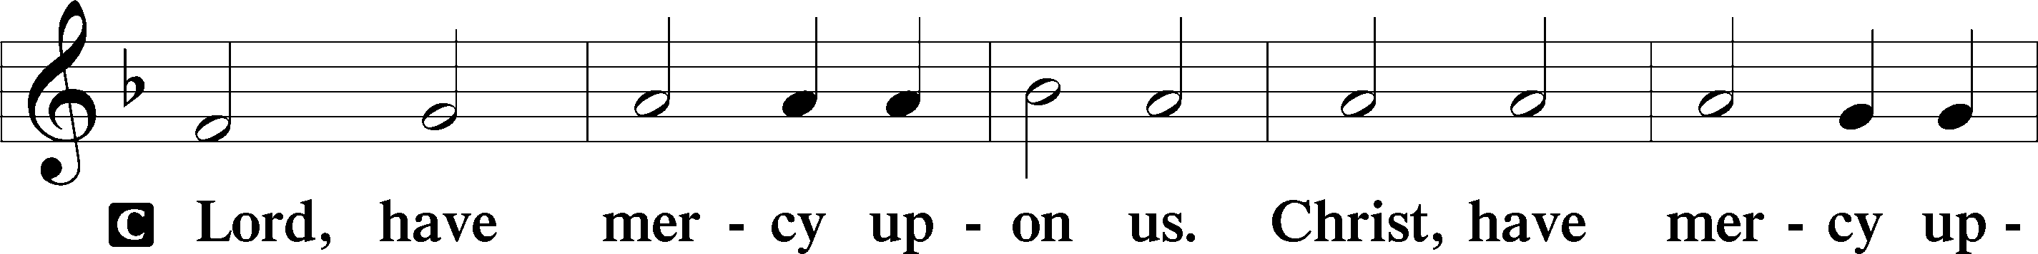
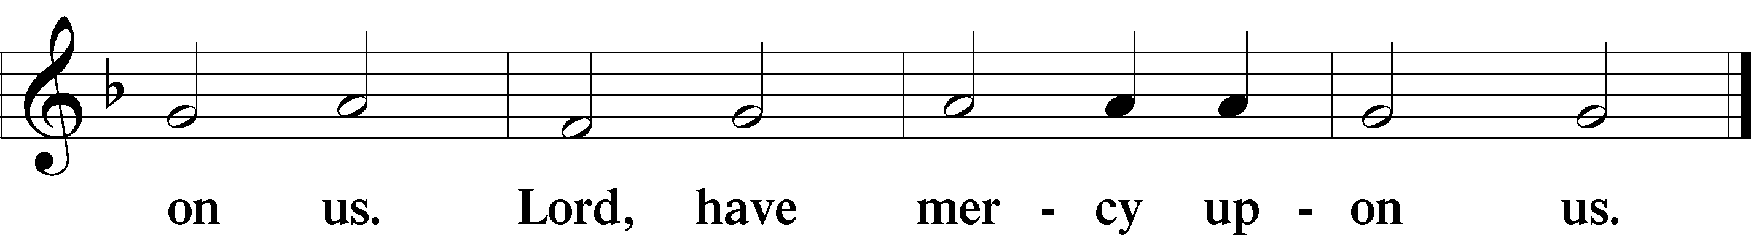

Gloria in Excelsis
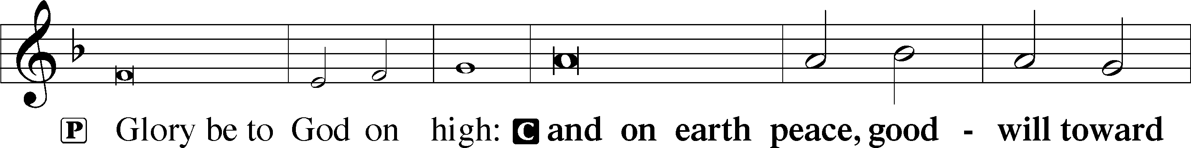
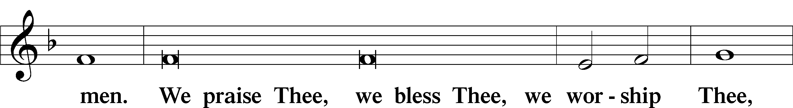
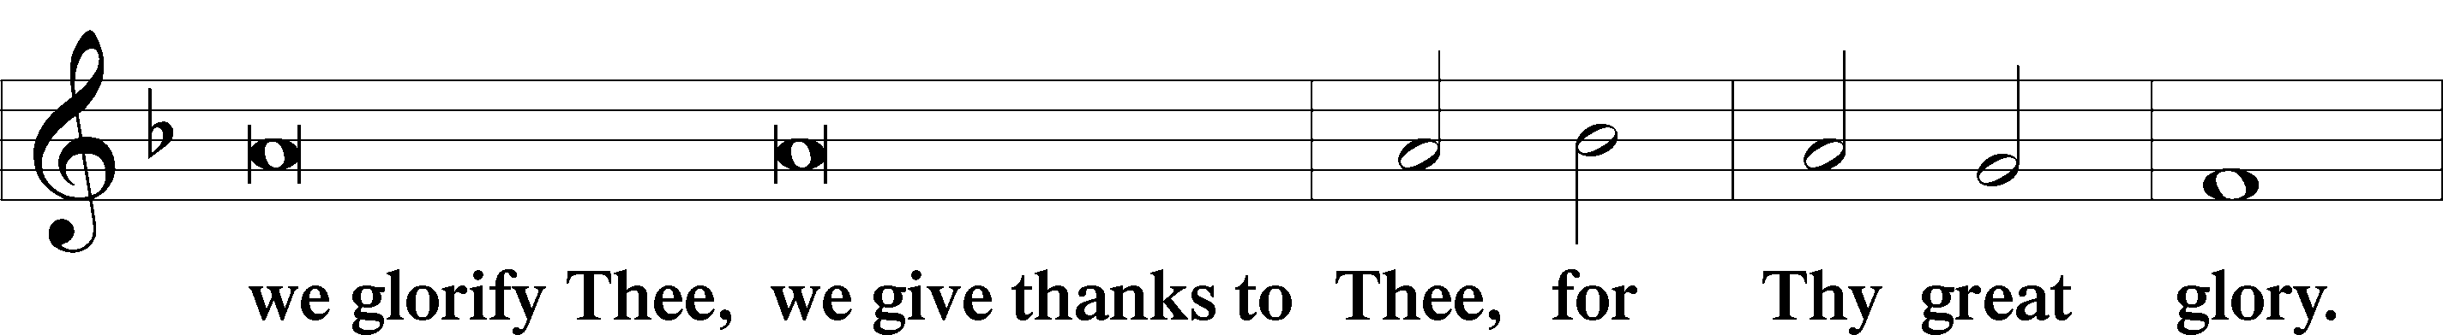
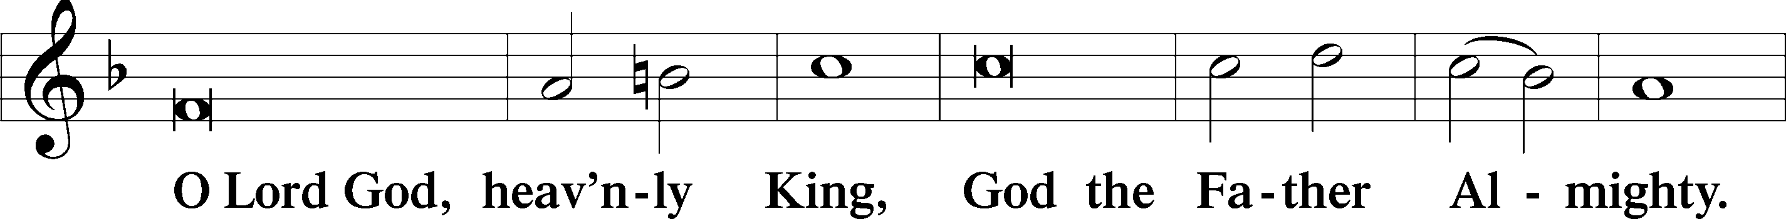
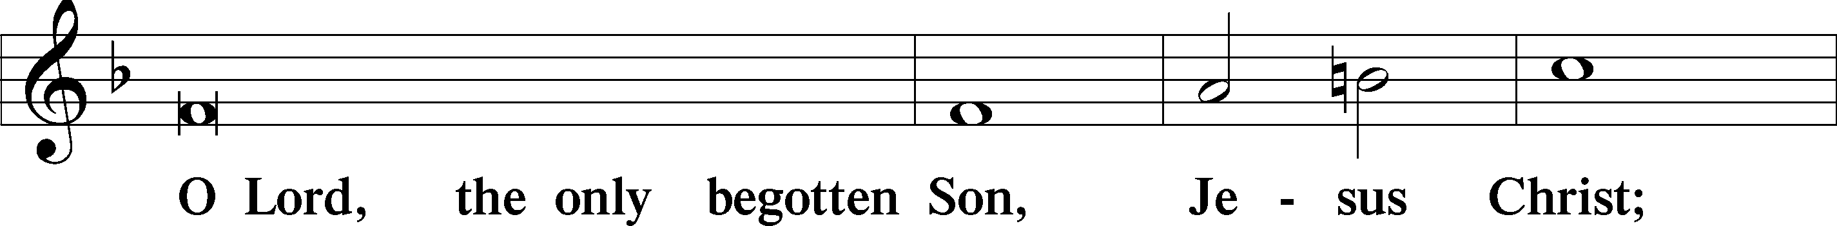
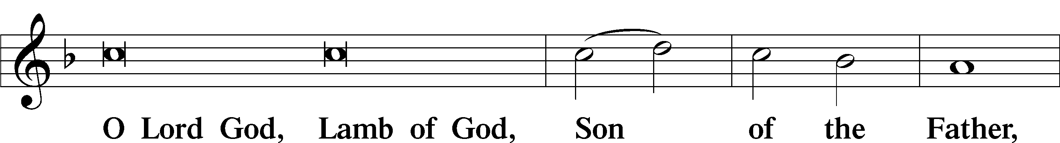
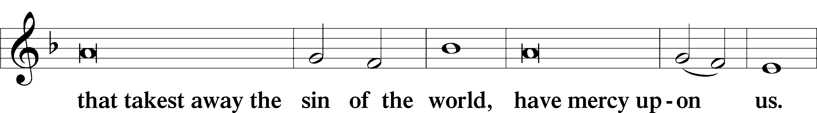
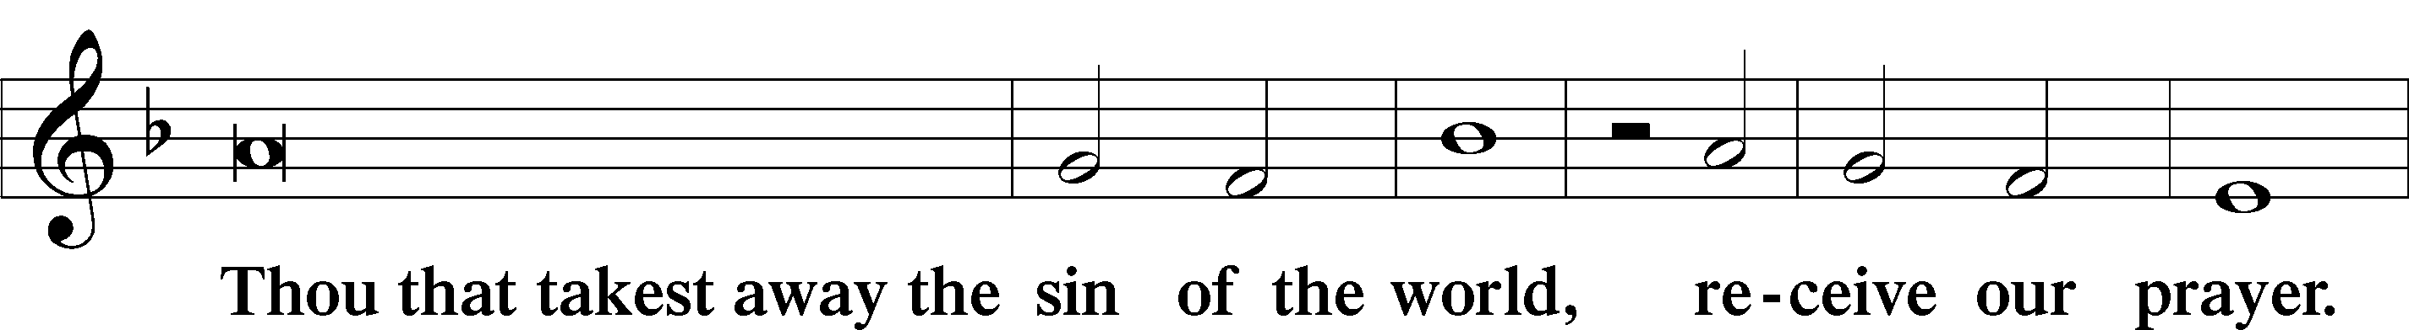
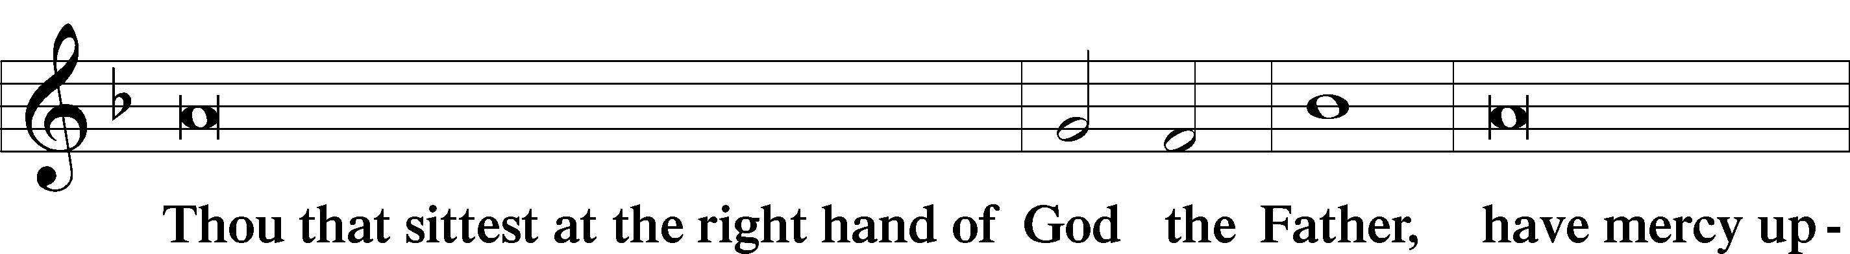
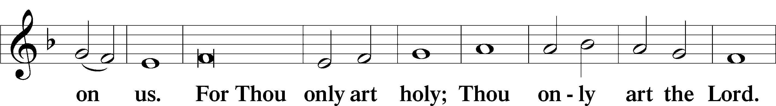
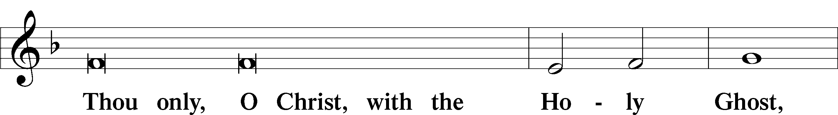
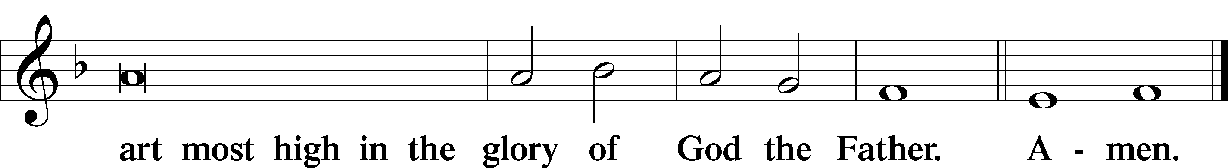

Salutation and Collect of the Day
P The Lord be with you.
C And with thy spirit.

P Let us pray.
C Almighty and Gracious Lord, pour out Your Holy Spirit on Your faithful people. Keep us steadfast in Your grace and truth, protect and deliver us in times of temptation, defend us against all enemies, and grant to Your Church Your saving peace; through Jesus Christ, Your Son, our Lord, who lives and reigns with You and the Holy Spirit, one God, now and forever. Amen.

Sit
First Reading Revelation 14:6-7
⁶Then I saw another angel flying directly overhead, with an Eternal Gospel to proclaim to those who dwell on earth, to every nation and tribe and language and people. ⁷And he said with a loud voice, “Fear God and give Him glory, because the hour of His judgment has come, and worship Him who made Heaven and earth, the sea and the springs of water.”

L This is the Word of the Lord.
C Thanks be to God

Gradual Psalm 48:1a, 12-14a
Great is the Lord and greatly | to be praised*
in the city | of our God!
Walk about Zion, go around her, number her | towers,*
consider well her ramparts, go through her | citadels,
that you may tell the next gener- | ation*
that this is God, our God forever and | ever.

Epistle Romans 3:19-28
¹⁹Now we know that whatever the law says it speaks to those who are under the law, so that every mouth may be stopped, and the whole world may be held accountable to God. ²⁰For by works of the law no human being will be justified in His sight, since through the law comes knowledge of sin.
²¹But now the righteousness of God has been manifested apart from the law, although the Law and the Prophets bear witness to it—²²the righteousness of God through faith in Jesus Christ for all who believe. For there is no distinction: ²³for all have sinned and fall short of the glory of God, ²⁴and are justified by His grace as a gift, through the redemption that is in Christ Jesus, ²⁵whom God put forward as a propitiation by His blood, to be received by faith. This was to show God’s righteousness, because in His divine forbearance He had passed over former sins. ²⁶It was to show His righteousness at the present time, so that He might be just and the justifier of the one who has faith in Jesus.
²⁷Then what becomes of our boasting? It is excluded. By what kind of law? By a law of works? No, but by the law of faith. ²⁸For we hold that one is justified by faith apart from works of the law.

L This is the Word of the Lord.
C Thanks be to God.

Stand
Alleluia & Verse Luke 12:32
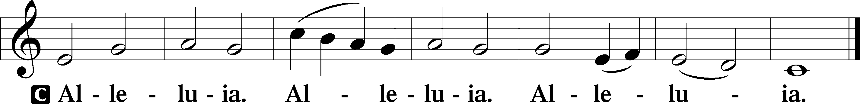

Fear not, | little flock,
for it is your Father’s good pleasure to give you the | Kingdom.

Holy Gospel John 8:31-36
P The Holy Gospel according to St. John, the eighth chapter:
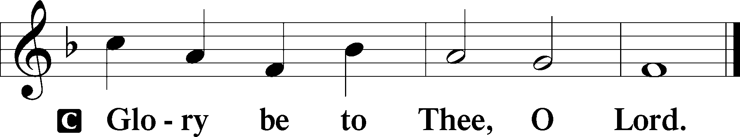

³¹So Jesus said to the Jews who had believed in Him, “If you abide in My Word, you are truly My disciples, ³²and you will know the truth, and the truth will set you free.” ³³They answered Him, “We are offspring of Abraham and have never been enslaved to anyone. How is it that you say, ‘You will become free’?”
³⁴Jesus answered them, “Truly, truly, I say to you, everyone who commits sin is a slave to sin. ³⁵The slave does not remain in the house forever; the son remains forever. ³⁶So if the Son sets you free, you will be free indeed.

P This is the Gospel of the Lord.
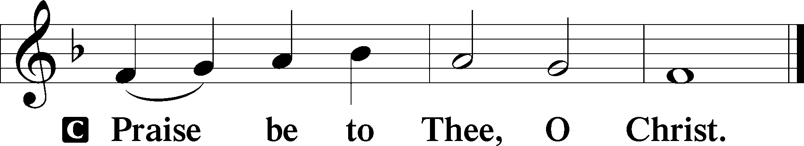

Nicene Creed
I believe in one God, the Father Almighty, Maker of Heaven and earth and of all things visible and invisible. And in one Lord Jesus Christ, the only-begotten Son of God, begotten of His Father before all worlds, God of God, Light of Light, very God of very God, begotten, not made, being of one substance with the Father, by whom all things were made; who for us men and for our salvation came down from Heaven and was incarnate by the Holy Spirit of the Virgin Mary and was made man; and was crucified also for us under Pontius Pilate. He suffered and was buried. And the third day He rose again according to the Scriptures and ascended into Heaven and sits at the right hand of the Father. And He will come again with glory to judge both the living and the dead, whose Kingdom will have no end. And I believe in the Holy Spirit, the Lord and Giver of life, who proceeds from the Father and the Son, who with the Father and the Son together is worshiped and glorified, who spoke by the prophets. And I believe in One Holy Christian and Apostolic Church, I acknowledge one Baptism for the remission of sins, and I look for the resurrection of the dead and the life T of the world to come. Amen.

Hymn of the Day A Mighty Fortress Is Our God 657

Sit
Sermon

Stand
Prayer of the Church
At the end of each petition:
P Let us pray to the Lord.
C Lord, have mercy.

Offertory
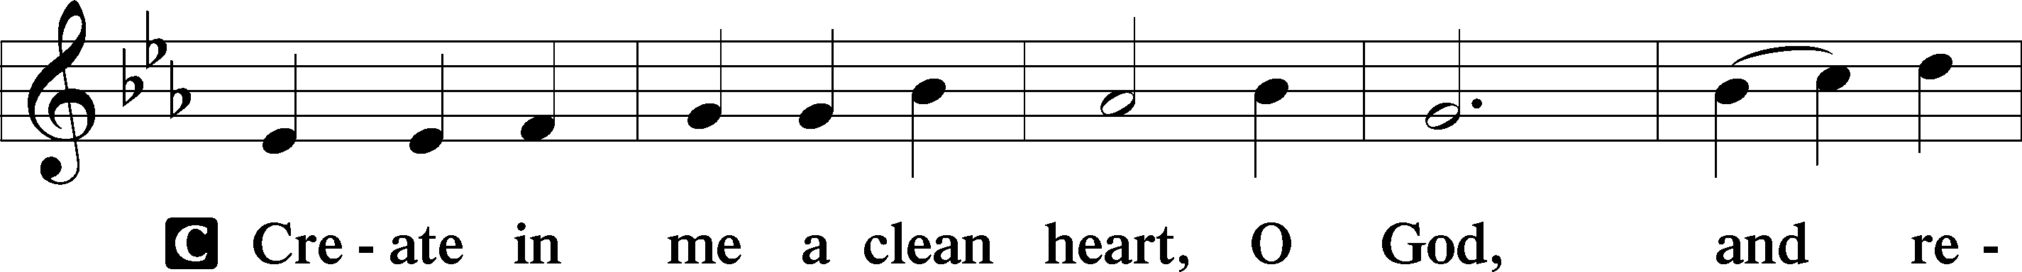
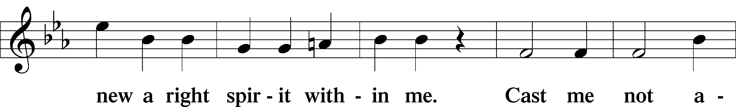
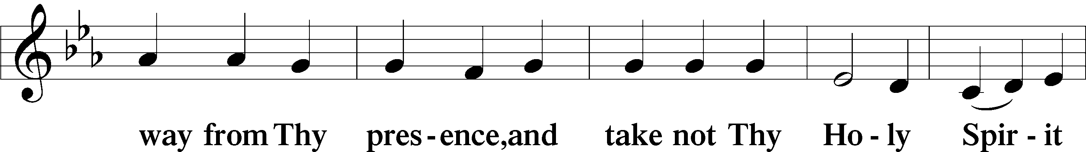
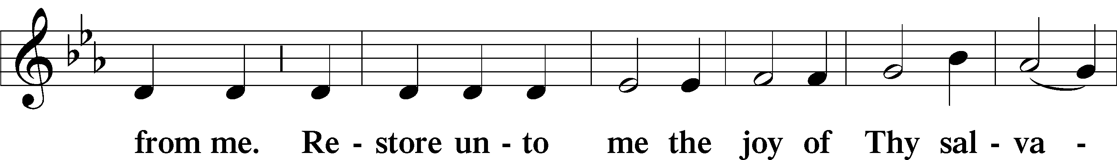
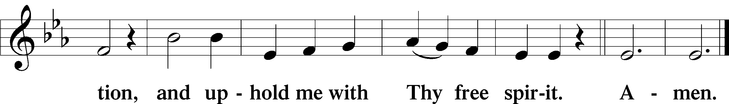

T Service of the Sacrament T

Preface
P The Lord be with you.
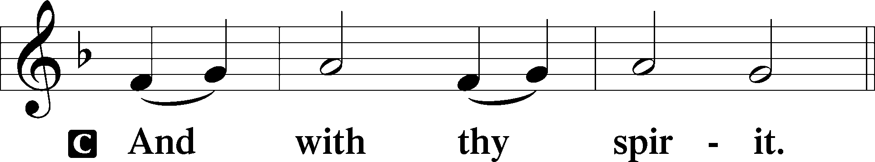

P Lift up your hearts.
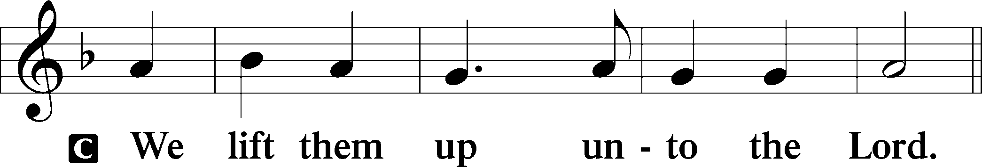

P Let us give thanks unto the Lord our God.
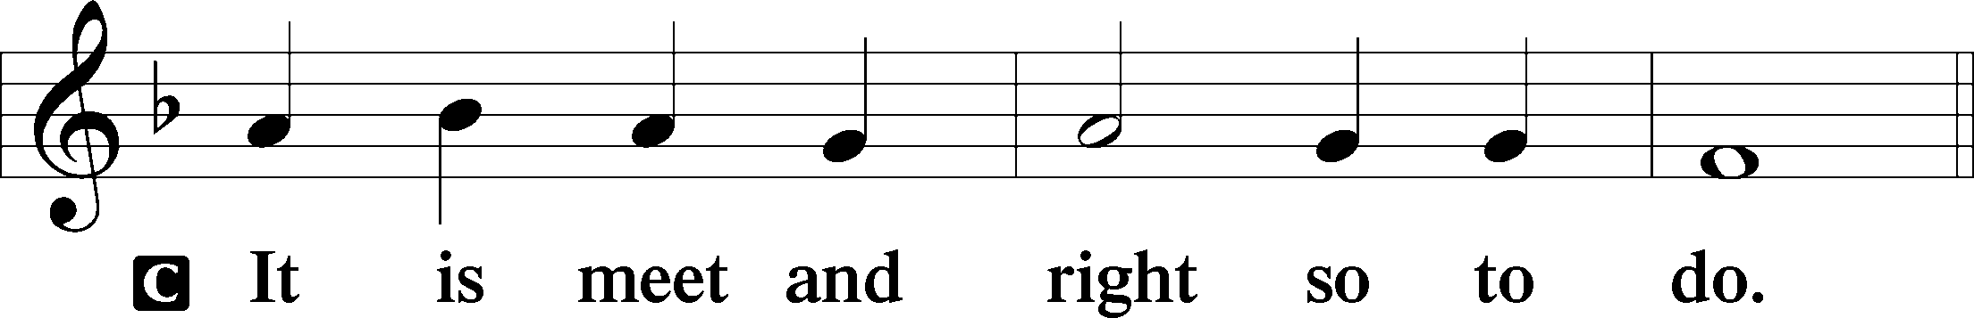

Proper Preface
It is truly meet, right, and salutary that we should at all times and in all places give thanks to You, Holy Lord, Almighty Father, Everlasting God, through Jesus Christ, our Lord, who, having created all things, took on human flesh and was born of the Virgin Mary. For our sake He died on the cross and rose from the dead to put an end to death, thus fulfilling Your will and gaining for You a holy people. Therefore with angels and archangels and with all the company of Heaven we laud and magnify Your Glorious Name, evermore praising You and saying:

Sanctus
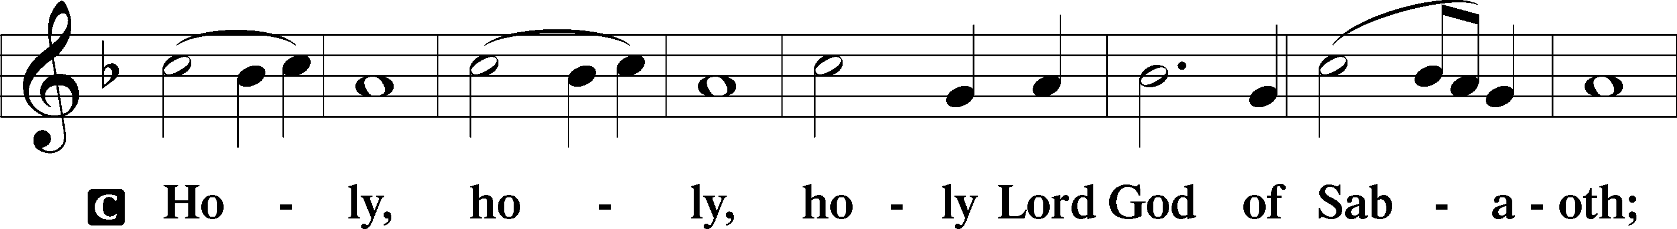
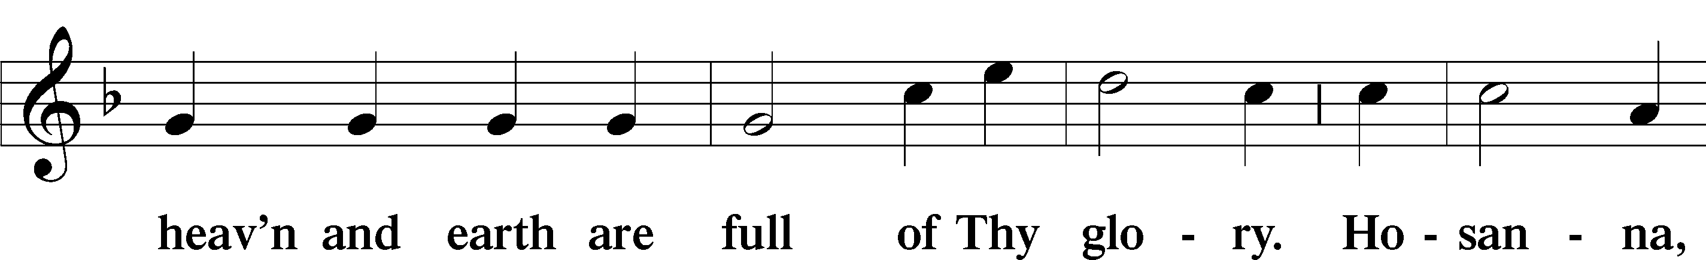
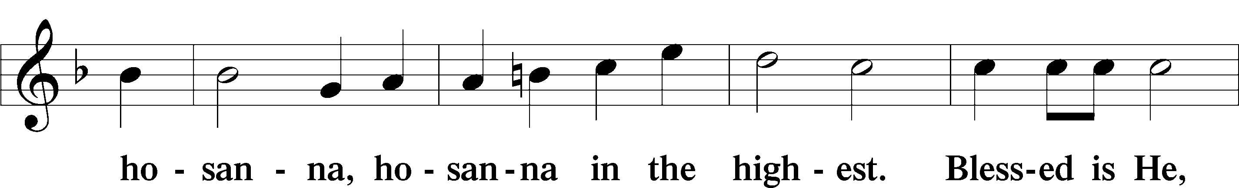
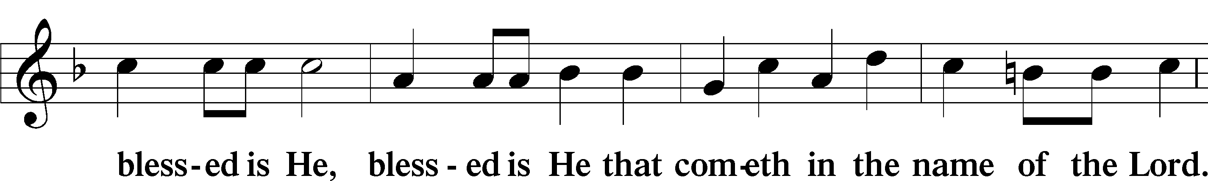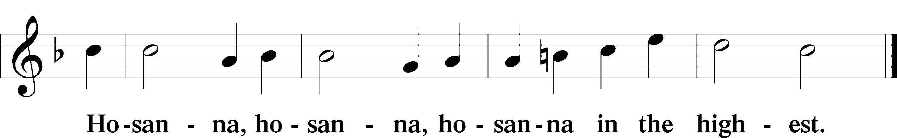

The Lord’s Prayer
Our Father who art in Heaven, hallowed be Thy Name, Thy Kingdom come, Thy Will be done on earth as it is in Heaven; give us this day our daily bread; and forgive us our trespasses as we forgive those who trespass against us; and lead us not into temptation, but T deliver us from evil. For Thine is the Kingdom and the power and the glory forever and ever. Amen.

The Words of Our Lord
Our Lord Jesus Christ, on the night when He was betrayed, took bread, and when He had given thanks, He broke it and gave it to the disciples and said: “Take, eat; this is My T Body, which is given for you. This do in remembrance of Me.”

In the same way also He took the cup after supper, and when He had given thanks, He gave it to them, saying: “Drink of it, all of you; this cup is the New Testament in My T Blood, which is shed for you for the forgiveness of sins. This do, as often as you drink it, in remembrance of Me.”

Pax Domini
P The peace of the Lord be with you always.
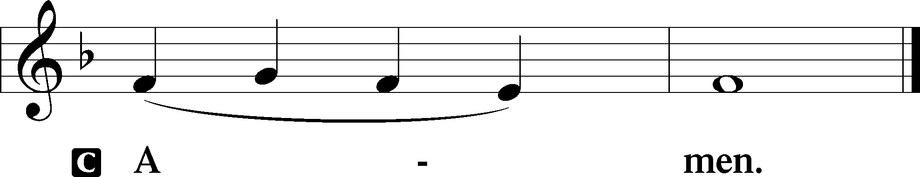

Agnus Dei
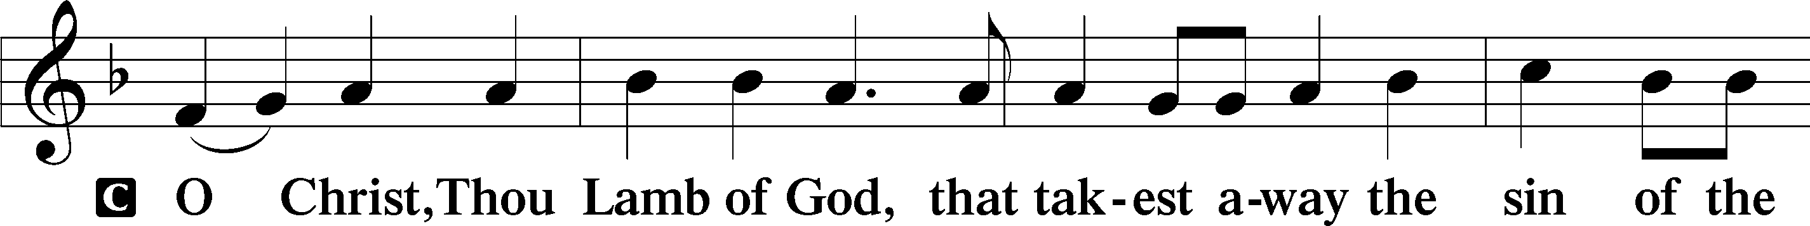
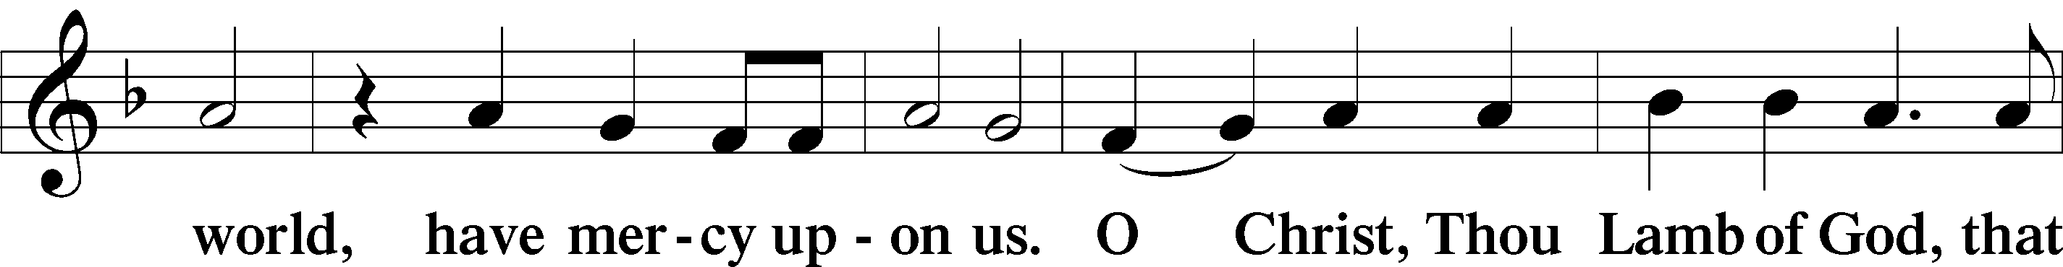
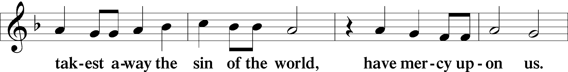
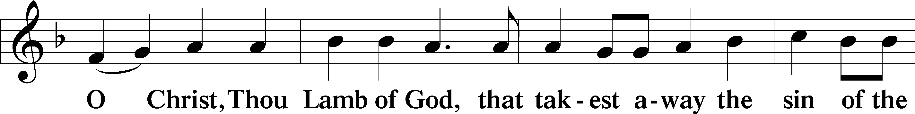

Our Lord Jesus Christ declares that the bread and wine in the Holy Communion are His body and blood, and are given to the faithful to eat and to drink for the forgiveness of sins and the assurance of salvation (Matthew 26:26-29; Luke 22:14-20). St. Paul writes to the church at Corinth: “Whoever, therefore, eats the bread or drinks the cup of the Lord in an unworthy manner will be guilty concerning the body and blood of the Lord. Let a person examine himself, then, and so eat of the bread and drink of the cup. For anyone who eats and drinks without discerning the body eats and drinks judgment on himself.” The Holy Communion is received worthily by those who are baptized in the Name of the Triune God, repent of all sin, are instructed in the Christian faith, trust our Lord’s words “given and shed for you for the forgiveness of sins,” and set aside any and all refusal to love and forgive others as God has loved and forgiven them. In so doing, they proclaim the Lord’s death until He comes again.

Because Holy Scripture warns against eating and drinking the body and blood of Christ in an unworthy manner, and because the Holy Communion is a confession of the faith that is confessed at this altar, first-time visitors, those who are not baptized and instructed in the Christian faith, those who are in doubt or hold a confession different from that of St. Paul Lutheran Church and The Lutheran Church—Missouri Synod, are kindly asked to speak with the pastor before communing. If you are not communing at the Lord’s Table today, but would still like to receive a blessing from the pastor, please cross your arms against your chest in the form of an “X” upon kneeling at the communion rail.

Sit
Distribution Hymns
O Lord, We Praise Thee 617
Thy Strong Word 578
The Church’s One Foundation 644
The Tree of Life 561

Stand
Nunc Dimittis
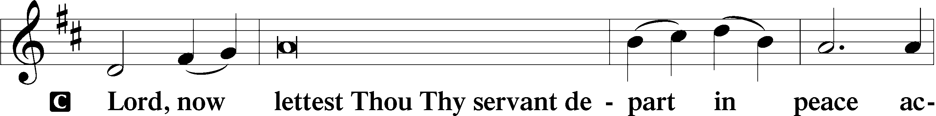
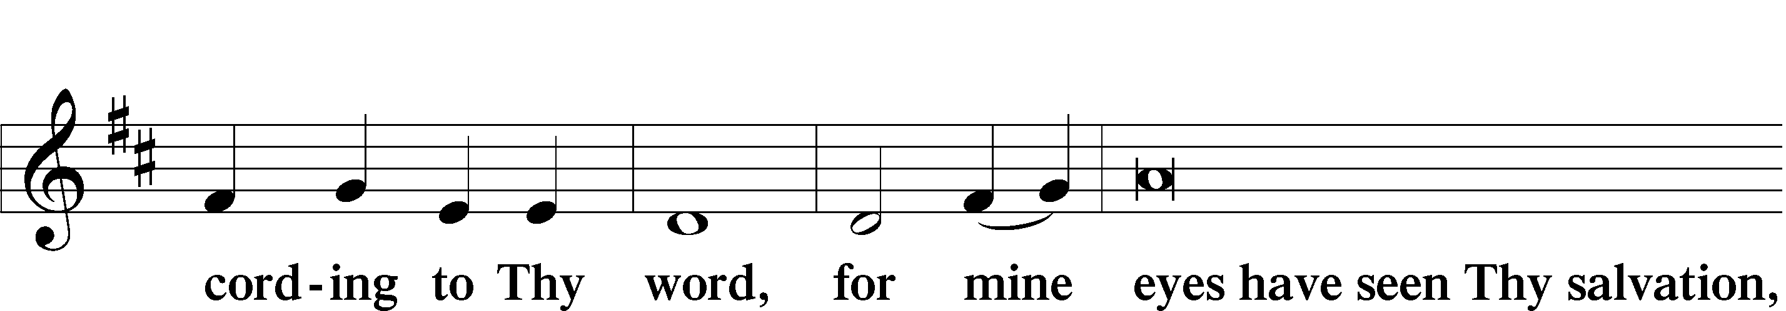
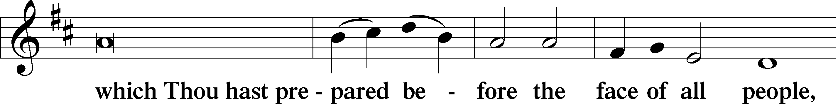
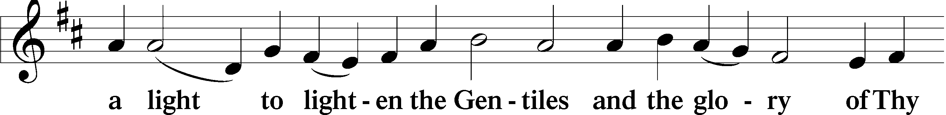
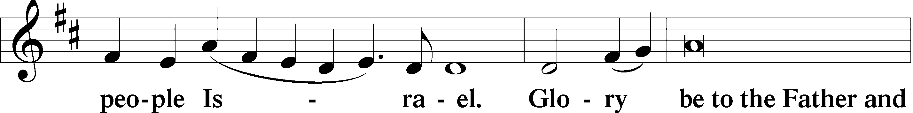
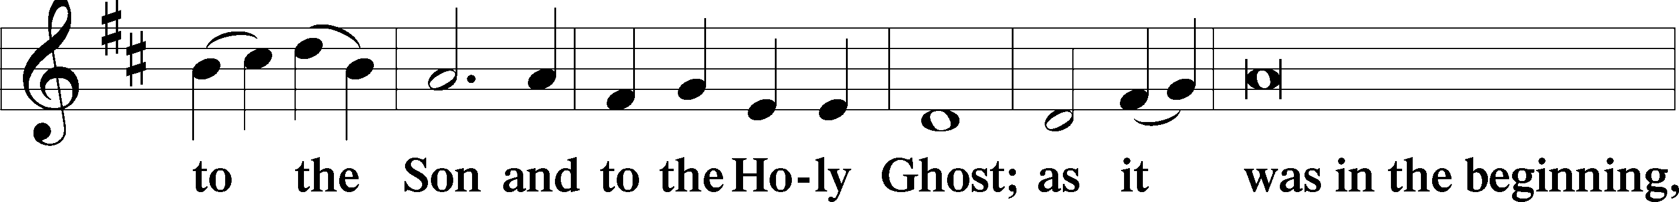
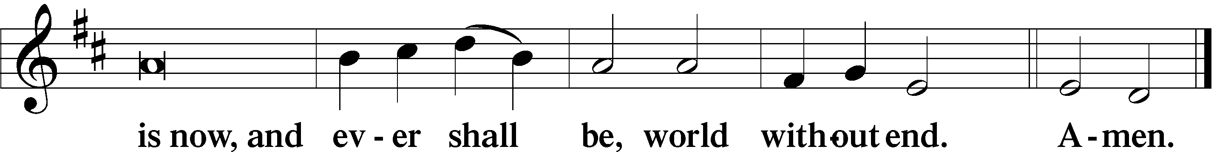

Thanksgiving
P O give thanks unto the Lord, for He is good.
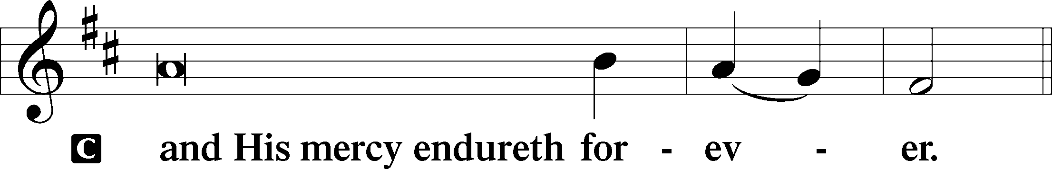

P Let us pray.
We give thanks to You, Almighty God, that You have refreshed us through this salutary gift, and we implore You that of Your mercy You would strengthen us through the same in faith toward You and in fervent love toward one another; through Jesus Christ, Your Son, our Lord, who lives and reigns with You and the Holy Spirit, one God, now and forever.

Salutation and Benedicamus
P The Lord be with you.
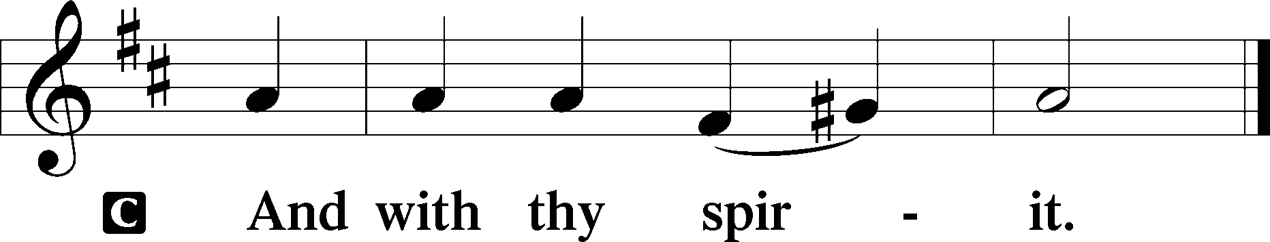

P Bless we the Lord.
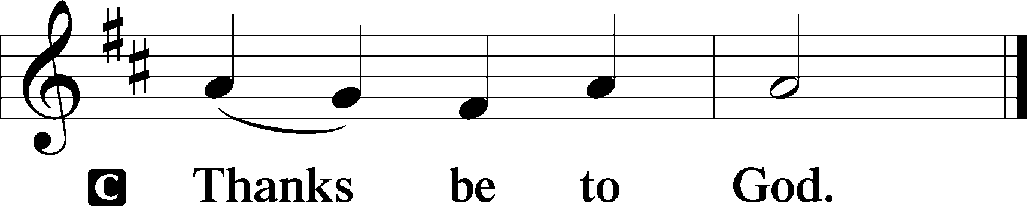

Benediction
P The Lord bless you and keep you.
The Lord make His face shine upon you and be gracious unto you.
The Lord lift up His countenance upon you and T give you peace.
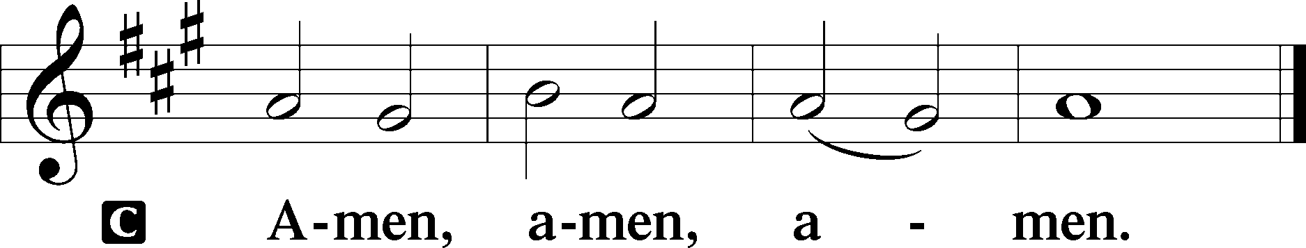

Hymn of Departure Dear Christians, One and All, Rejoice 556

Flowers under the cross are given in celebration of
Dolores Charlesworth’s birthday.
—Doc Dalbey

Honored By Christ T T T Honored To Serve
Pastor Rev. Jeffrey Proctor
ElderS Joel Moreno, Darrell Ahrens
LECTOR Delores Townsend
Worship Assistant John Peterman
Music Assistant Amanda Fust
Altar Guild Mary Howard
Ushers Robert Moreno, Isabel Moreno
GREETER Doc Dalbey
COUNTERS Bea Hendricks, Rose Tressler
AUDIO/VIDEO Kevin Stamm
You are invited to Irmer Hall for coffee/cookies & fellowship following the Divine Service.

ST. PAUL LUTHERAN CHURCH
6301 W. Indian School Road, Phoenix, Arizona 85033
Office hours (Sept. – Dec.): M, W, F 10:00a.m. – 2:30p.m.
and T, Th 2:30p.m.-4:00p.m.| 623.846.2228
Email: info@stpaullutheran-az.com Website: www.stpaullutheran-az.com
Pastor Jeff Proctor, Cell Phone: (260) 494-7622 Email: pastorproctor@hotmail.com

“To Shine Forth the Light of God’s Love into Our World”

BULLETIN NEWS

This Week’s Calendar

Sunday, October 27 Location
9:30am Divine Service Sanctuary
11:15am Adult Bible Class (Ezra) Irmer Hall
Sunday School Irmer Hall

Wednesday, October 30
1:00pm Mid-week Bible Study (James) Library

Thursday, October 31
6:00pm Thursdays with Luther Library
(Letters of Spiritual Counsel)

Saturday, November 2
10:00am Matins Sanctuary
Birthday
10/29 – Michael Moreno 10/31 – Dolores Charlesworth 10/31 – Katrina Tressler

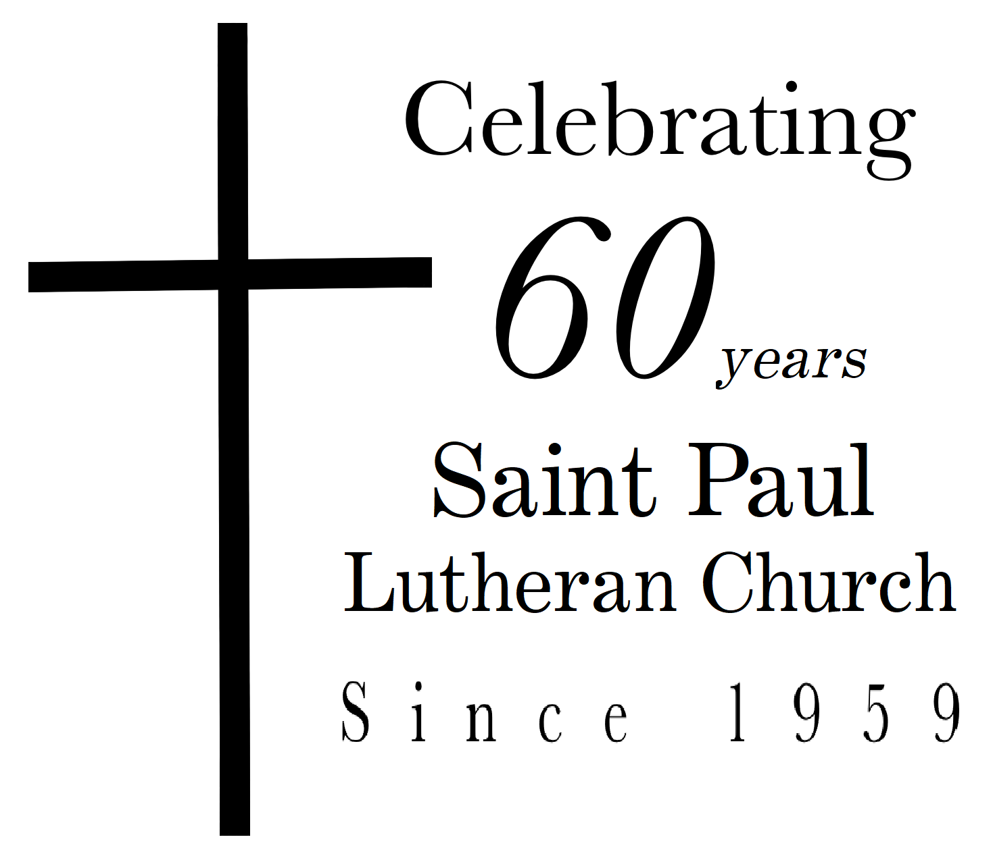
“TID-BIT” OF ST. PAUL HISTORY
In the 1980s, the Bethel Bible Series was initiated and led by committed and trained lay people in our congregation. This was a weekly series that focused on Bible reading and assignments that many of our members attended. The Stephen Ministry Program was also adopted as part of our congregation in the 80s. This program enabled trained lay persons to minister to those in our congregation who expressed a need for emotional support and were referred by the pastors.

PATHS TO LUTHERANISM
Issues, Etc. is a radio talk show and podcast produced by Lutheran Public Radio in Collinsville, IL and hosted by LCMS pastor Todd Wilken. This week’s lineup features guests detailing their journeys to Lutheranism from Roman Catholic, Mainline Protestant, Calvinist, Anglican, Baptist, and Pentecostal backgrounds. You can listen at www.issuesetc.org and on the LPR mobile app.

LEXINGTON LIFE ACADEMY — ”TRUNK OR TREAT”
Lexington Life Academy will host a “trunk or treat” on Friday, November 1, 2019 from 6-8pm. The school has extended an invitation to the members of Saint Paul to join the fun. This would be a good opportunity for the church to meet the faculty and families of Lexington Life Academy and invite them to join us on a Sunday morning. Pastor Proctor and his family will be there.
THANKS BE TO GOD. . .
For all the willing hands who assisted in planning and preparation in any way for celebration of St. Paul’s 60th Anniversary. Each effort made a contribution as we praise God for His past, continuing and future blessings of this congregation.

This week as of October 23, 2019
let us pray for…
Please keep this list available for your daily devotions. For prayer requests Church office (623) 846-2228, 10 a.m.-2:30 p.m. or email at info@stpaullutheran-az.com. Prayer requests are removed after three weeks.

ON-GOING CONCERNS:
Dorothy Anderson – fighting lung cancer | Anita Norgren – receiving treatment for lymphoma.
Doc Dalbey – recovering from a fall | Lindalee Martinez – recovering from hysterectomy
Otillia Wartell – receiving hemodialysis | Gary Moser – pulmonary embolism
Pat Haas – recovering from back surgery | Dan Kuhajda – health concerns
Judith Kuhajda – ongoing health issues | Laura Jimenez – kidney failure
Nicholas Jimenez, Linda Rossow, Jim Rucker

FAMILY AND FRIENDS:
William Petersen, former boss of Mary Howard, is recovering from open heart surgery.
Don and Marylou, parents of Dan Meredith, Don has terminal cancer-brain tumor.
Ivy and Annie Fadness, aunt and cousin of Roger and Delores Townsend, both have severe health issues.
Angel Lopez, neighbor of Lindalee Martinez, recovering from stroke.

MISSIONARIES SUPPORTED BY ST. PAUL:
Rev. Stephen Oliver, wife Maggie and children, serving in Taiwan and the Asia Region.
Rev. Adam DeGroot, wife Melissa and son, serving in Albuquerque, NM.

PRAY FOR ST. PAUL LUTHERAN CHURCH:
The Rev. Jeff Proctor, his wife, Joan, and children, Christian, Olivia, Nigel, Fiona & Siwan
Sunday School teachers & children LCMS day schools, high schools, universities, and seminaries
Maryvale Preparatory Academy families & staff Lexington Life Academy families and staff

OUR NATION: The President of the United States and his advisors, as well as the Governor of Arizona and all who make and administer the laws in our land.

FOR THOSE IN THE MILITARY (members, friends or relatives): Gary Morris, Joseph J. Yungkans, Clay Faras, Lindsey Keene, Juan Garcia, Tiffany Gilmore, Robert Gilmore, Ethan Peterman, Mike Nguyen,
Jacob Wilson

OUR SHUT-INS: Suzanne Berna, Debbie Hand, Barbara Sand, Lori Townsend, Frank Walsh,
Arbutus Wood

Acknowledgments: Divine Service, Setting Three from Lutheran Service Book © 2006 permission.

